GAME PRODUCTION 2
FINAL REPORT

Number: N01197349
Full Name: Murat Avartani
Title: Developer / Test Engineer

- PRESENTATION OF WORK

Summary
As a developer / test engineer of this project, I have mainly worked on building the designed mechanic solutions to achieve smooth movement and camera transitions. I have also worked for three different powerups, respawning, replication of movement on the network and implementation of car assets.

  - Achieved Developer Work
- I have created 10 cpp/header files. Names: ACar.cpp...
- I have created 40 functions. Names: Move(), CameraTuner()…
- I have created 5 installment documents (Documents are attached to submission)
- Fixed 5 bugs posted on the Help channel

  - Achieved Test Engineer Work
- I have run 50 Test cases
- I have found 1 critical, 4 major, 15 minor bugs and 7 improvement suggestions
- I have created 11 test case documents (Documents are attached to submission)

  - Achieved Side Task Work
- I have imported 5 objects retrieved from artists
- I have helped solution team to create a solution for pickups
- Communicated 6 weeks on discord to clarify unclear requirements
- Helped design team to come up with new pickup abilities

- GOALS
  - Developer Goals
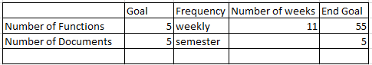

    - Number of Functions: I have developer 15 functions less than my goals due my workforce is moved to bug fix to fix 5 bugs for this portion of my goals.
    - Number of Documents: I have created 5 Installment Document as it is set in my goals.

  - Test Engineer Goals
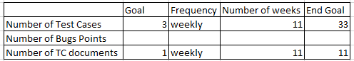

    - Number of Test Cases: I have run 17 more test cases than my goals
    - Number of TC Documents: I have created three less TC documents due my workforce is moved to Solution and Design teams as mentioned in 1.3. Achieved Side Task Work for this portion of my goals.

